npm install -g @angular/cli

ng version (next generation for web application) Angular

to create new project

ng new project-name if ask any policy question you can enter yes or no.

routing -🡪No

styling 🡪css (enter)

then after project created move inside a project folder using command as

cd project-name

to run the project we need to run the command as

ng serve -o after compiled 100% it will open in default browser with url

as <http://localhost:42000>

now open the project in VS code.

.json (JavaScript object notation)

Project folder

src folder

app folder

app.component.html html page is known as template

app.component.css external css file like styles.css

app.component.ts

app.module.ts

Component component is use to control the view or part of the view.

Angular is component based architecture framework.

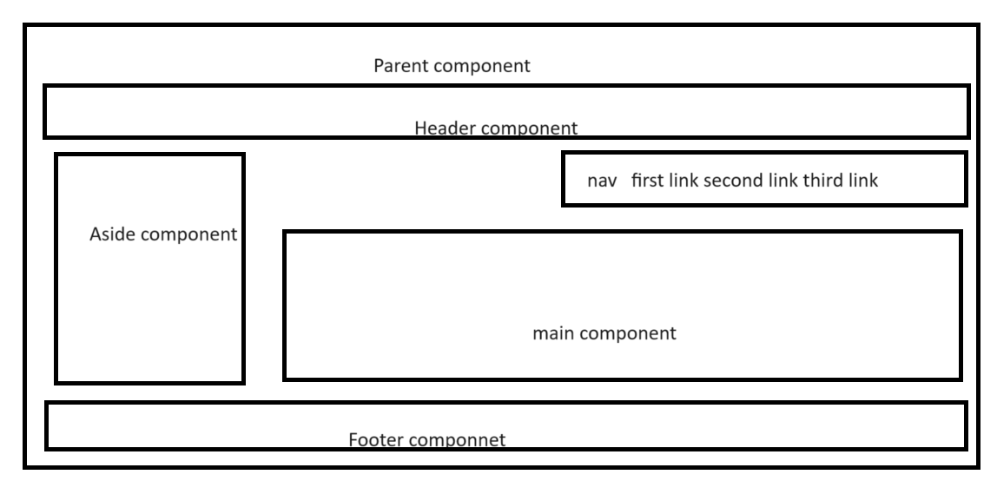

Angular use Typescript class concept to create user defined component.

@Component : Decorator or annotation : it is special functions. It is use to add extra functionality to class.

This decorator contains lot of property like

Selector

templateUrl : it is use to connect html or template page.

stylesUrl : it is use to connect external css file

class Employee {

}

With help of component we are creating user defined tags.

In angular using selector attribute we can create user defined tags.

<h1>Welcome</h1>

<p>Welcome</p>

<app-root></app-root> where ever we use <app-root></app-root> the contents which present inside template display on that place.

Component : it is use to control the view or part of view or using

Component we can create user defined tags.

Module : collection of more than one component etc.

@NgModule decorator :

Declaration : in this section we need to provide all component details.

Import : in this section we can import pre defined or user defined modules.

BrowserModule: this module is responsible to display output on browser

Providers : in this section we have to provide angular service class details.

Bootstrap : in this section we need provide parent component details to load that component

We will create user defined component

child.component.ts

child.component.html

child.component.css

if we want to create component please use angular cli command

open another terminal ie external or vs code terminal

ng generate component component-name

or

ng g c component-name

ng g c header

ng g c footer

these command create component insider header and footer folder.

Please check the component selector name which present in that component ts file. And use that selector as tag inside any html page base upon our requirements.

Data binding

Data binding provide bridge between component to template or vice-versa.

Using data binding we can share the data between component to template or template to component.

2 types of data binding

1. One way data binding : uni directional
   1. String interpolation : it is a type of one way data binding

Component to View or template

.ts ----🡪 .html

Syntax

{{}}

Example

{{variableName}}

{{5+7}}

{{functionName()}}

1. Two way data binding : bi directional

Create new project with name as angular-data-binding

ng new angular-data-binding

routing 🡪 no

styling 🡪 css enter

cd angular-data-binding

ng serve -o

then open the project in vs code

please open app.component.html : remove all code and write below code.

<div>

  <h2>Angular data binding concept</h2>

</div>

ng g c string-interpolation